Northern Hills Community Association
Summary of Board Meeting
Nov 27, 2019
GUEST UPDATES
Presidents Update | - Successful business fair, hope to expand upon it in the future  - Will clarify Objects for AGM in April 2020  - Casino approved for April 2020
MLA Calgary North East Office | - Calgary North High School Approval  - CFEP grant approved to NHCA & Creating Coventry  - Residential Access Modification Program grant expanded  - Inspiration Awards 2020 Call for Nominations Open till Jan 13th, 2020
MLA Calgary Beddington Office | - Reports from NHCA submitted
MP Calgary Nose Hill Office | - MP re-elected in 2019  - Summer Jobs application will be opening soon  - Openness to meet with board
Vivo Representative | - ALEX community health bus will be here every other week starting Dec. 2nd to Jan 2020 in Vivo parking lot  - Vivo expansion planning underway, full construction may start in 2021  - Play Project (Coventry, Panorama, etc.) - December 2019 and January 2020  - Tenants Update last week with some action items for the future
NPC | - See report attached  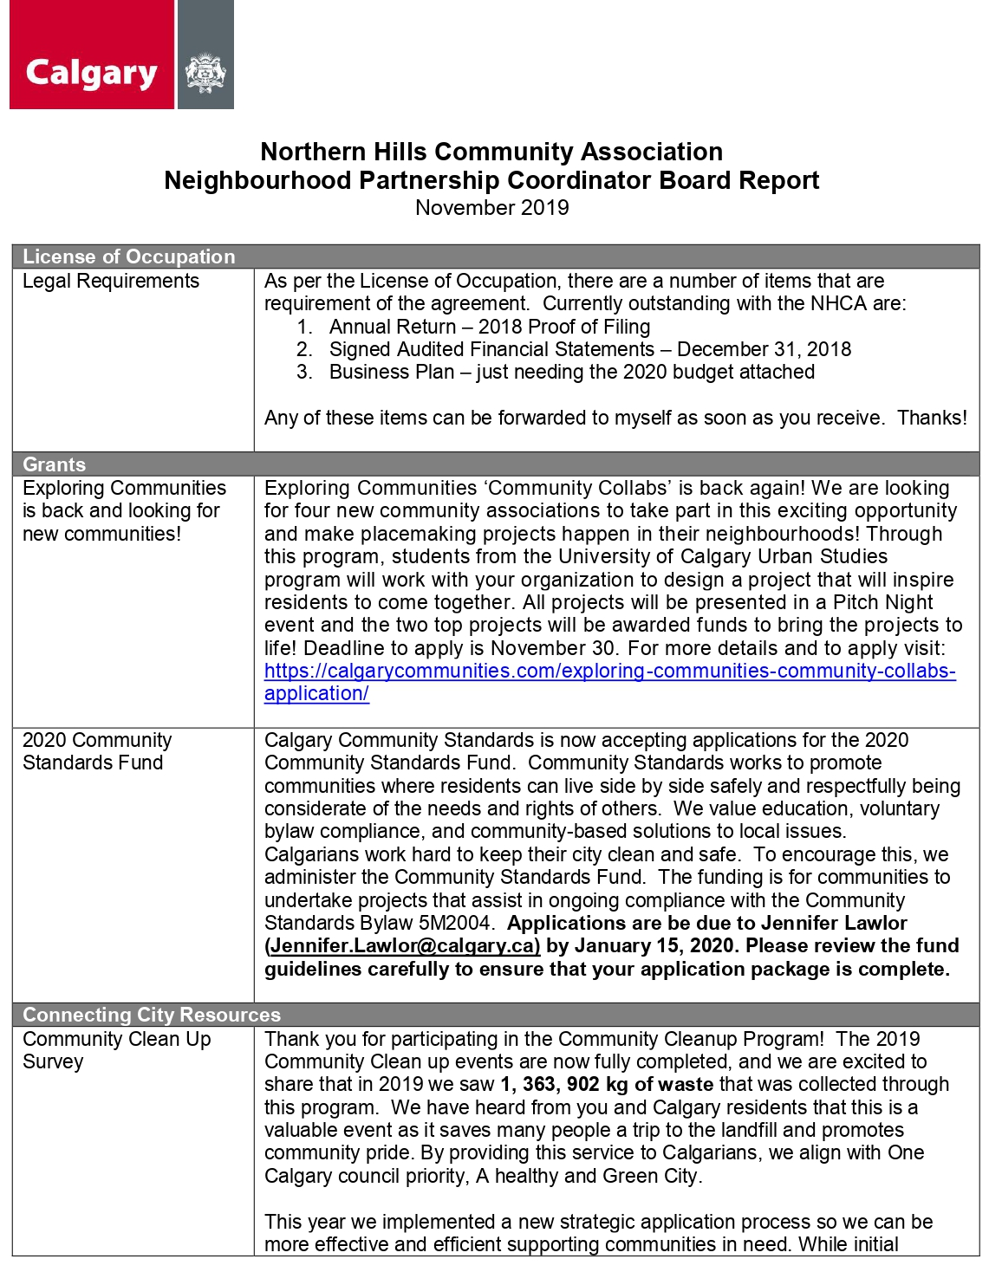
Uplyft (volunteer organization) | - Sanya and Josh of Uplyft present, they used to be part of the NHCA youth council  - Registered non-profit  - Education about domestic violence throughout school years  - Go in junior highs and high school and give presentations about healthy relationships and domestic violence  - Health Friendships, Intimate Relationships & Dating, Domestic Violence  - Peer-based model vs. Expert-based model  - 15-20 workshops, reaching close to 100 students in the past year  - Plan to expand to 30 new groups in 2020  - Publish curriculum and digitize with the students  - Barrier to funding for the year because they don't have charity status  - Asking for funding from NHCA for recruitment, publishing a paper, switching to digital means  - Workshops focused all across the city  - Ultimate goal is to be put in the CALM program in high school  - Follow-up feedback - student and staff satisfaction surveys  - A Motion was made: "Be it that the NHCA table this request for further discussion." All in Favour, None Opposed, Motion Carried
Creating Coventry Update (Moraig) | <<Creating Coventry Update Nov 2019.pptx>>
SPRY (Senior Persons Regaining Youth) Update (J-L Edmond) | - Representation and thanks  - The program is at capacity
BOARD BUSINESS
New Potential Director | Glen  - Got involved in the Block Watch for his area  - Second NHCA meeting he has attended  - A Motion was made: "Glen Smith is accepted as a Director at Large with the NHCA"  - All in Favour, Motion Carried
Executive Update | - Special Meeting follow-up  - Went well  - Director at Large, not X Director  - Board Manual Org Chart - Committees vs Projects Activity
Committee Exercise | - Premise:  - We have too many committees, different types  - Standing vs. Ad-hoc vs. Projects  - Board groups committees together
Secretary | - Transparency and engagement for Board Meetings  - A lot of information is passed to us during board meetings, and the information is not effectively passed on to our community members or residents at this moment; Recommendations from Secretary:  - FB Live of our Guest Portion only  - Update NHCA Website with written notes  (Redact names within notes) - Under Construction  - A Motion was made: “BE IT RESOLVED THAT the NHCA will upload and maintain all non-closed and non-in camera regular board meeting minutes on a web platform that is normally accessible by the general members of the NHCA."  All in Favor, None Opposed, Motion Carried  - A Motion was made: “BE IT RESOLVED THAT the NHCA may, pursuant to NHCA policy and procedures, publish guest portions of regular board meetings to platforms accessible by the public and the general members of the NHCA, with the approval of said guests and the NHCA."  All in Favor, None Opposed, Motion Carried
Finance | - Dashboard  - YTD Financial Results, will send them out soon  - Discussion about using AGLC funds for beautification and signage  - Call to Order Made
Fundraising | - AGLC & Casino update - April 14-15th, 2020  - Save-A-Date Reminde
Events & Programs | - Showcase & Fair (Business Fair) results  - 4-5 Stars for Feedback from Vendors  - Put feedback together for next year, perhaps create template for next year  - Gift of Joy - Saturday, Dec 14 – see handouts  - Call out for Volunteers  - As it is a sensitive event, prefer board members and no children, to provide security for the event  - Request for funding from NHCA  - There is potential that the WCEF grant does not come through, results from the grant will come out around Dec 11, but the event will happen shortly after, not enough turnaround time to purchase gifts  - The average gift cost will be around $50.00  - Spreadsheet is listed under "Events" --> "Gift of Joy"  - General Letter template to businesses available  - Families are selected through the organization Bow West  - A Motion was made "BE IT RESOLVED THAT the NHCA provide funding to the NHCA Gift of Joy program."  - All in Favour, None Opposed, Motion Carried  - NSRA partnership agreement (Skatetacular, Community Clean-up, etc.)  - Skatetacular - Jan 26, Feb 23, March 15.  - AGM planning needs to start in January – needs a director-based committee
Membership | - IVRNet vs CiviCRM.  - Conflict of Interest occurs, should Ian assist to develop software for NHCA's use  - Membership Coupons, 2020 pricing  - Membership Development Planning update  A Motion was made: “BE IT RESOLVED THAT the NHCA adopts the Resolution titled "Membership Software Procurement Project", reference 20191127-2.  All in Favour, None Opposed, Motion Carried  - Ian McAnerin has abstained from voting  - It is acknowledged that the NHCA contacted the FCC about the ASM procurement and potential conflict of interest process and this resolution is a result of their advice.  - It is acknowledged that Ian McAnerin (President) is both an expert on procurement and in a potential conflict of interest position as a potential provider of ASM software.  - He agrees to have no part in the independent decision making process and may only provide specific advice on direct request by the committee.  - Motion Defeated  - More details to be brought in next meeting about
Planning | No Report  Update Filed - No Discussion Needed
Volunteer | - Casino needs volunteers - aim for 50  - Plan to recruit volunteers?  - Volunteer Committee would like to purchase blank certificates and certificate holders for presenting certificates of appreciation or outstanding contribution to volunteers and key individuals.
NHN Newsletter | - Administrative Assistant responsibility  - Advertising cancellation policy  - There was a complaint at the Business Fair from a vendor who wanted to pull out their NHN ad due to placement at the Business Fair  - 2020 Health issue. Other special issues?  - April is "National Health Month"  - Content from local health practitioners  - Put out a "Special Edition"  - Idea: Resource Issue  - During AB Cultural Days (summer 2020)
Advocacy | - North Calgary High School funding announced November 1  - Future of ANCHS advocacy group  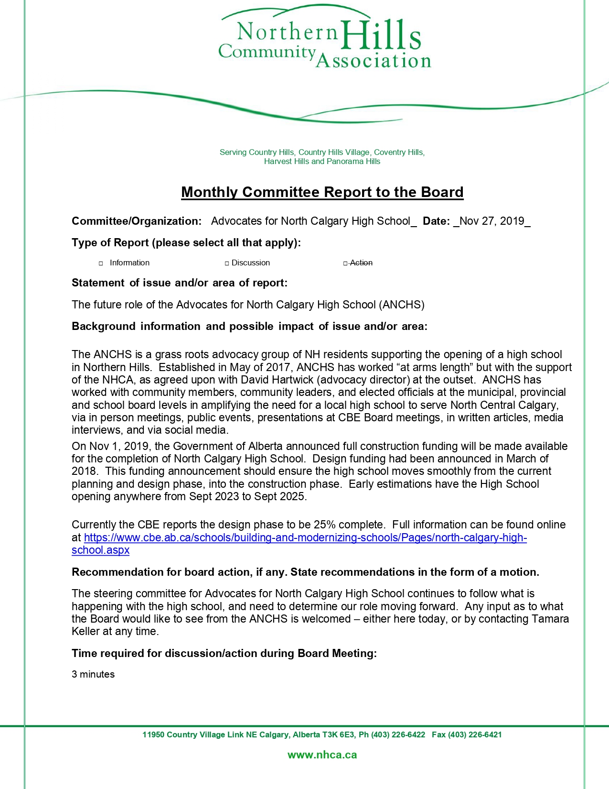  ANCHS Board Committee Report Nov 2019.docx>>
Sports | - Website on NHCA is not accessible/most efficient  - Soccertech has taken on Slo-pitch  - Previously, it was found that the program had been breaking even, though NHCA was losing money on the program  - Will start up the program again, and try to improve the program and monitor the finances further  - Registration for Soccer and Slo-pitch will happen in Jan. 1st, 2020  - Feb 28 is a Registration Event  - $20.00 Late registration fee will be enforced (previously not enforced)  - Re-word it "Early Sign-up Discount" -- positive reinforcement  - Conflict of Interest with Vivo facility usage for some sports  - Will need other spaces for other than Soccer and Slo-pitch  - Exploring potential of Sports-specific volunteers  - Coaches, team managers  - Cleaned out storage cabin  - Equipment:  - Soccer Nets will be used by Creating Coventry  - Shin pads will be taken by Second Chance Sports (who will donate these further)
Arts and Crafts | - Submitted partnership agreement to NSRA to continue our art programs.  - Pop-up craft pending Dec 14
AHIH | - Tax Clinic 2020 is a tentative go; same organizers as last time;  - Will be recruiting volunteers for Tax Clinic 2020 soon (deadline Jan. 7th, 2020)
Northern Hills Connect | - Final Community Soup of the year scheduled for Thursday Nov 28. Free to attend – would love to see more board members out.
Beautification and Gardens | - Discussion of using AGLC funds for beautification and gardens
Harvest Hills Hub | - Grant financial reporting  - Completed
BSC / BlockWatch | - Crime statistics showing reduction/maintenance  - Meeting with CROs soon  - Information will be attached
Harvest Hills Hub | No Report
Rinks | - Rink Liner pricing stated
SPRY in the Hills | - Program is full
Marketing | - Vision 2020 Introduction  - Marketing Calendar worksheet  - Vision 2020 presentation and Marketing calendar planning
IT | - Discussion on laptops and technology needed going forward and fudning needed for this.  A Motion was made: “BE IT RESOLVED THAT the NHCA purchase or acquire the recommended 2 laptops, 1 projector, and 4 monitors.  All in Favor, None Opposed, Motion Carried
Parent Link – Support Letter | 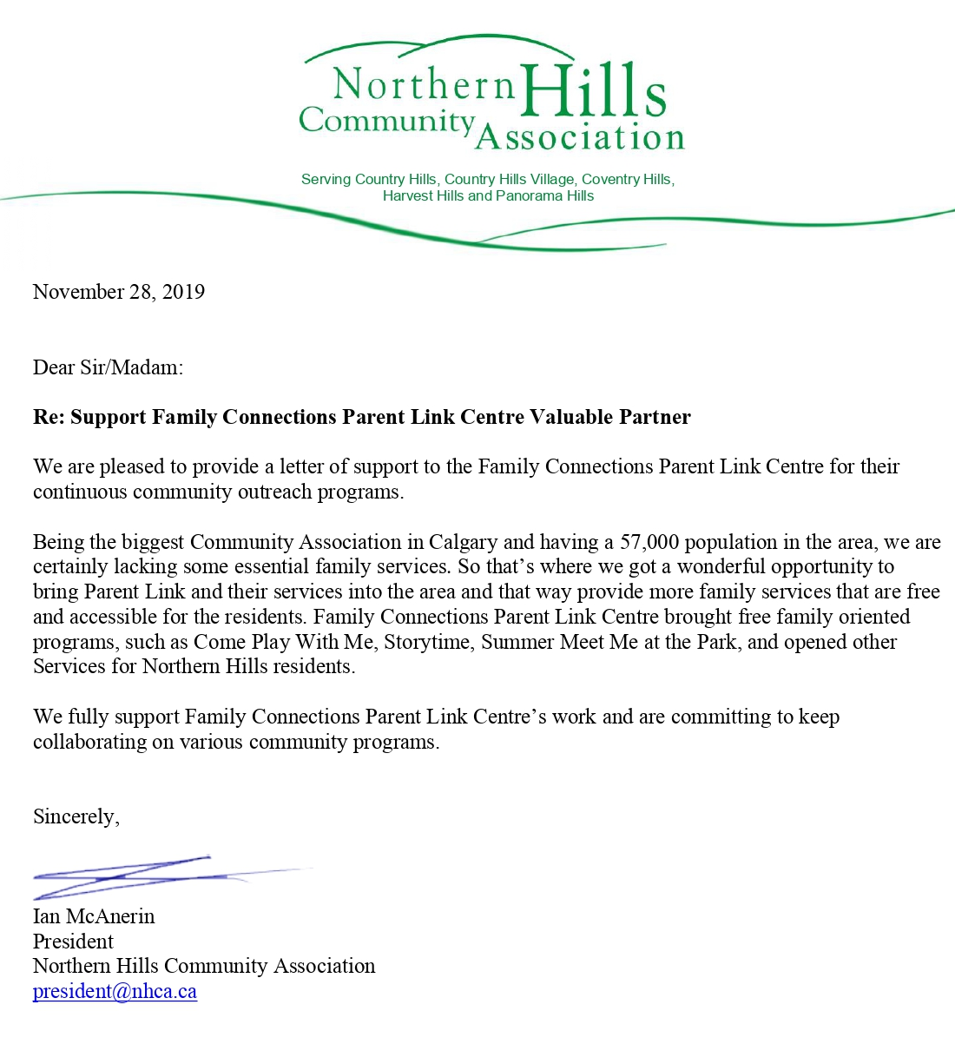  Parent Link is our partner with who we deliver free family programs and services for the Northern Hills area. They asked us for a letter of support as with the recent provincial budget cuts they need to re-apply for the funding and this letter would be part of their application.  Here is a draft with a few points about the programs we do with them:  A Motion was made: “BE IT RESOLVED THAT the NHCA write a letter of support for Parent Link in order to facilitate their grant writing process."  All in Favour, None Opposed, Motion Carried
Summer Student Grant Application | Canada Summer Jobs – Federal Grant  Call for Applications: December 2019 - Early February 2020
UpLyft Request for funding | - Discussion about vulnerable youth and sensitivity to the program  - Due diligence required  Motion: "BE IT RESOLVED that the NHCA table the motion to provide Uplyft with funding based on the condition that a workshop be offered in the area in NHCA."  All in Favour, None Opposed, Motion Carried
MOTION TO ADJOURN | A Motion to Adjourn was called at: 10:37pm  All in Favor, None Opposed, Motion Carried

