Northern Hills Community Mural Project
Call for Artists RFP Submission Form

Thank you for your interest in responding to the Northern Hills Community Mural Project RFP. Please download and review the Call for Artists RFP prior to completing this Submission Form.

Please check the project webpage for revisions to the RFP at –
www.northernhills.ab.ca/call-for-artist-mural-project/.

All questions are to be directed to the Mural Committee with the subject line “RFP Question,” and emailed to Mural@NorthernHills.ab.ca. If the subject line is not used, we miss your email when sorting emails by this descriptor.

RFP Submission Deadline: Thursday, May 31, 2018 at 12:00 pm

Mural Installation Date: August 4-6, 2018

Artist Contact Information
Name
 | First Name |  | Last Name
Phone
Email
Website
Address
City |  |  |  | Postal Code
team members if submitting as an artist-led team
Team | First Name | Last Name |  |  | City |  | Website if Available
Member 1
Member 2
Member 3
Member 4
Member 5
Member 6

REFERENCES
Please provide three (3) references below.
Reference 1
 | First Name | Last Name
Phone
Email

Reference 2
 | First Name | Last Name
Phone
Email

Reference 3
 | First Name | Last Name
Phone
Email

Artist Bio (175 words max.)

ART EXPERIENCE (2 pages max.)

Images of Mural Artwork |  | - Please submit 3-5 digital images representative of your previous mural work or representative of the work you would like to submit.  - Please name each file using the following format:  FirstLast#; e.g. JaneDoe1.jpg, JaneDoe2.jpg, JaneDoe3.jpg  - Image File Format: PDF or JPEG  - Image File Size: 8x10; no more than 2 MB in size per image
Image 1 | Date Completed: |  |  | Website
 | Dimensions:
 | Medium:
 | Location:
 | Title:
 | Client:
Image 2 | Date Completed: |  |  | Website
 | Dimensions:
 | Medium:
 | Location:
 | Title:
 | Client:
Image 3 | Date Completed: |  |  | Website
 | Dimensions:
 | Medium:
 | Location:
 | Title:
 | Client:
Image 4 | Date Completed: |  |  | Website
 | Dimensions:
 | Medium:
 | Location:
 | Title:
 | Client:
Image 5 | Date Completed: |  |  | Website
 | Dimensions:
 | Medium:
 | Location:
 | Title:
 | Client:

Community Engagement Experience (1 page max.)

Proposed Nhca Community Engagement Plan (2 pages max.)

Proposed Mural Painting Weekend Plan (1 page max.)
The goal is to break a world mural record by inviting 14,000 people to paint a mural on an 850 metre long, 20,000 sqft fence line in 3 days on Aug. 4-6, 2018.
How would you propose to best manage the people who will be painting the mural throughout the weekend to ensure this goal is achieved?

Proposed MAterials for the Mural (1 page max.)
Q1 | What paint would you recommend using to paint the mural in consideration of the NHCA commitment to ensure it lasts for at least 8 years?
Q2 | What primer would you recommend using on the wooden fence as an undercoat for the mural?  The existing fence is about 15 years old and has been previously painted which is now peeling off per the photos provided in the RFP.
Q3 | Would you recommend using a UV protection on the mural?  If yes, what UV protection top coat do you recommend?
Q4 | What anti-graffiti coating would you recommend using for the mural?
Q5 | How many paint brushes do you recommend we have available to complete the mural with 14,000 people in 3 days over the August long weekend?

Submission Checklist
Your submission should include the following:
- Completed and signed submission form.
- Contact information for three (3) references.
- A brief artist bio statement.
- Summary of visual art experience.
- 3-5 photo images of your previous mural work in either PDF or JPEG format.
- Summary of community engagement experience.
- Proposed Northern Hills mural project community engagement plan.
- Proposed project plan to manage 14,000 people during the painting of the mural on Aug. 4-6.
- Recommended paint material products to complete the mural.

SIGNATURE
I, the undersigned Artist, have carefully reviewed the Northern Hills Mural Project Call for Artists RFP document, including all Appendices and any clarifications or revisions posted on the mural project webpage, understand and agree to the requirements and processes as outlined in the RFP.

Without limiting the forgoing, I understand:
- Late submissions will not be accepted.
- Incomplete submissions will not be accepted.
- Submissions sent via the provided project email address will only be accepted.
- All submission files must be sent in one email.
Date:
Please Print Name of Artist / Lead Artist Submitting this Proposal
Signature of Artist / Lead Artist Submitting this Proposal

Special thanks to our valued project partners!
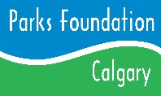
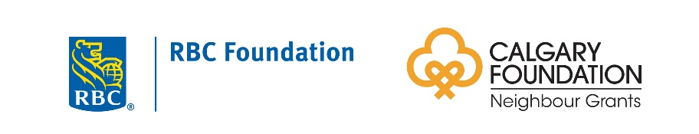
Anilin Decorating Centre

